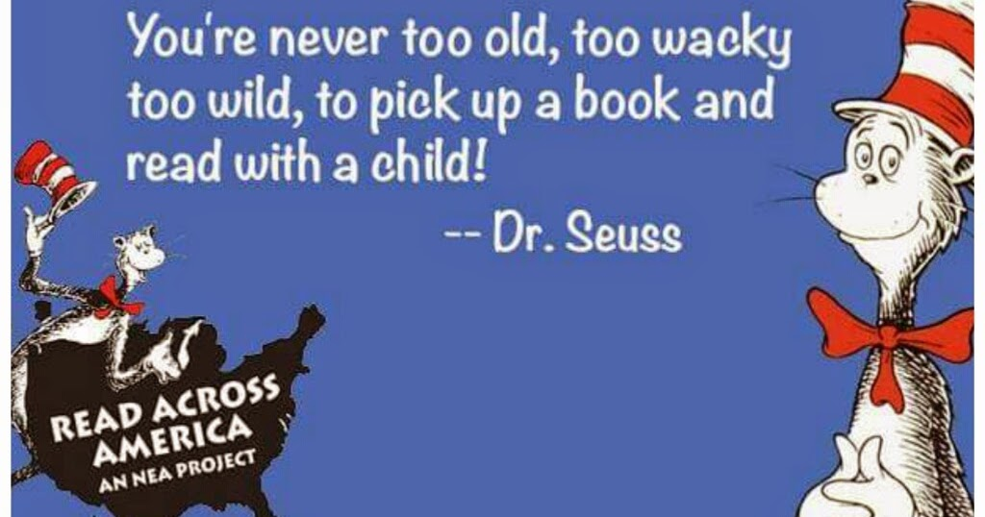

Greetings!

We are excited to announce that Asa G. Hilliard Elementary School is hosting a Literacy Day Celebration in honor of Dr. Seuss’ birthday. Dr. Seuss contributed many books that have brought about excitement and a love for reading in our children. We want to instill in our students the importance of being lifelong readers and show them how much fun that reading can bring, and, “Oh, the Places They Will Go!”

We have several activities planned for “Dr. Seuss’ Week”. Throughout the week, students will participate in a live chat with students from another elementary school in Fulton County to discuss a novel that they both have read. They will compare and contrast characters, point of view, and analyze and evaluate the plot and theme.

This day of exemplifying the joy and fun of reading will be held on Monday, March 2, 2020 from 8:30 A.M. – 11:00 A.M. at Asa G. Hilliard Elementary School. Our hope is that you will participate with us as a reader. You will read a book to one or more classes. This should take no more than 15-20 minutes per book. The books will be available for you once you arrive. You will have time to become familiar with your book before going to the class. We know that everyone has a busy schedule, so if you cannot participate the entire time, let us know what time is convenient for you and we will schedule accordingly.

Please send us a response by Monday, February 24, 2020 to let us know if you can participate. We know that you will enjoy the time that you spend with us here at Asa G. Hilliard Elementary School.

Sincerely,

Miranda Weems and Christine Harper

Literacy Team

Asa G. Hilliard Elementary School